1. Install Node.js - <https://nodejs.org/en/download>
2. Install dependencies:
   1. $ npm install
   2. $ npm install webpack -g
   3. $ webpack
3. Install web server:
   1. $ npm install webpack-dev-server –g
   2. $ webpack-dev-server
4. Add Eclipse plugin: Nodeclipse  
   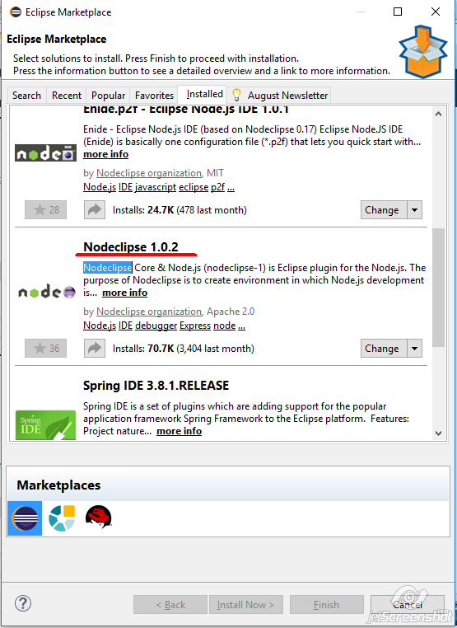
5. Create Eclipse run configuration:  
   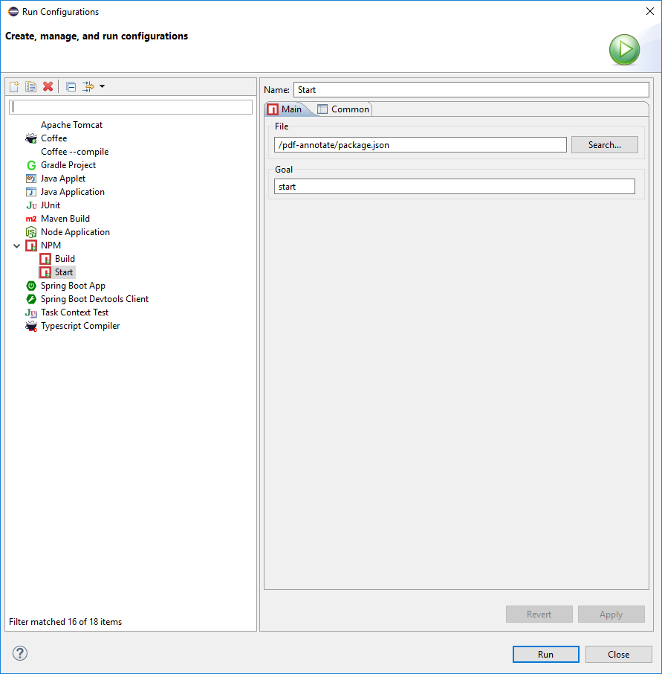
6. Open http://localhost:8080/webpack-dev-server/  
   